
Voltage Control Relay 100A
Fit and Forget Installation Instructions

Pre - Installation
- Disconnect both batteries by removing both the positive and negative terminals before commencing installation.
- Ensure the Auxiliary Battery is mounted securely to prevent movement in any direction
Location
- The Baintech Voltage Control Relay (VCR) should be mounted on a flat dry surface under the bonnet such as a firewall
- The Baintech VCR must be kept well away from hot items, such as exhaust systems or turbo chargers
Attaching Cables
Before cables can be attached to the batteries you will need to attach a lug to the end. Please follow the instructions below for attaching Lugs
- Strip the plastic casing off the end of the cable for approximately 15mm, fit the appropriate connector and crimp in place.
- Slide the heat shrink over the connectors and heat with flame or heat gun until secure
- Attach the lugs to the batteries as per the cable connection instructions
Cable Connection
- Attach one end of the positive (red) cable to the positive terminal of the auxiliary battery.
- Run the cable to the VCR, keeping the cable away from any moving parts and cut to size.
- Attach the exposed section of cable to the positive terminal of the start battery.
- Attach both positive (red) cables to the VCR. The cable attached to the start battery goes to M6 stud labelled ‘30’, and the cable connected to the auxiliary battery goes to the M6 stud labelled ‘87’
- Use a spade connector to attach one end of the small negative/earth (black) cable to the VCR terminal labelled minus ‘86’.
- Connect the other end of the small negative/earth cable to the closest earth connection (usually the mounting point of the VCR or on a clean paint free metal surface)
- Attach one end of the large negative/earth (black) cable to the negative terminal of the auxiliary battery
- Connect the other end to the closest earth connection usually the chassis of the motor vehicle, engine block or alternator, or where possible to the negative battery terminal.

For safety reasons please ensure to use DC fuses on the positive cables where possible.
Refer to the installation diagram in Figure 1.

Bainbridge technologies :: 1224 Lytton Rd Hemmant :: www.baintech.com.au :: 1300 224 864

Options
If you want to use the emergency Parallel feature or winch bypass, you can make a switched connection from the terminal marked ‘85’, to the positive terminal on the auxiliary battery.
- For safety please ensure to use DC fuses on the positive cables where possible.
- Refer to the installation diagram in figure 1

Testing
- Reconnect the primary starting battery
- Start your engine
- Set your multimeter to a DC volts range above your battery voltage to be measured.
- Place the red multimeter probe to the M6 screw terminal labelled ‘30’. Then place the black multimeter probe to the ‘negative – VCR Earth point’ this is the mounting point of the Baintech VCR to the vehicle chassis, (86).
- The voltage should quickly reach 13 volts (26v for the 24v system); this may vary in time depending on the type of vehicle. Once the voltage reaches 13.2 volts (26.4v) you will hear an audible click, this means the relay has switched to allow current charge through to the Auxiliary Battery. This can simply be tested by continually touching with the red multimeter probe to the M6 screw terminal labelled ‘Auxiliary battery ’ (87) When the VCR is closed, Voltage on both ‘30’ and ‘87’ will be the same.

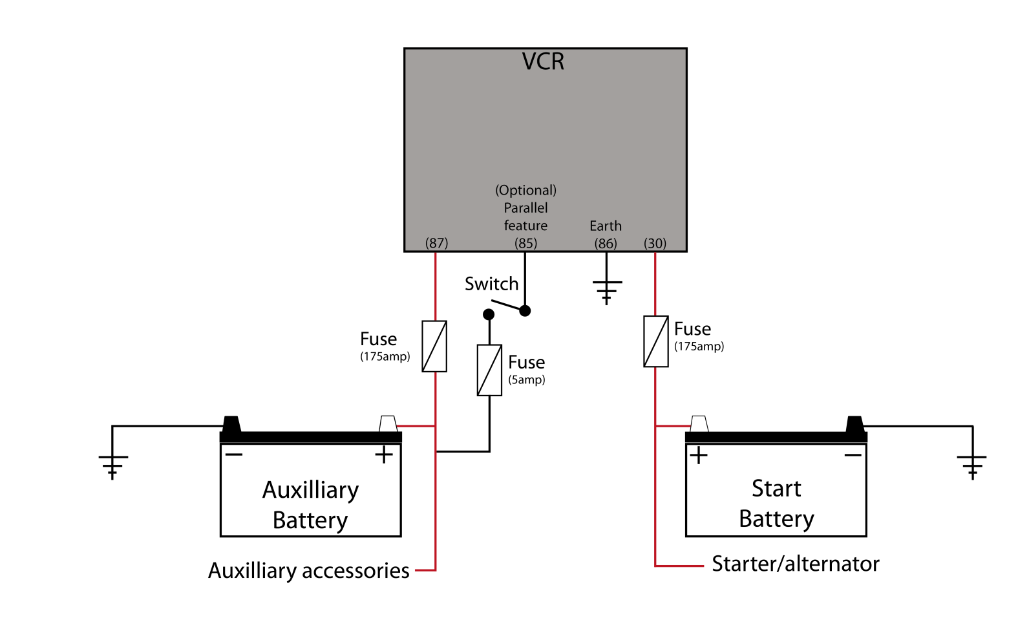
The Baintech VCR installation is now complete.
Figure 1:
(100Amp)
(100Amp)
Bainbridge technologies :: 1224 Lytton Rd Hemmant :: www.baintech.com.au :: 1300 224 864

